## Five Number Summary and Mean:

|  |  |  |  |
| --- | --- | --- | --- |
|  | Class A | Class B | Both (All Scores) |
| Mean | 80.5 | 87.3 | 84.55 |
| Mode | 88 | 100 | 100 |
|  |  |  |  |
| Min | 66 | 72 | 66 |
| Q1 | 74 | 80 | 78 |
| Q2 | 78 | 88 | 86 |
| Q3 | 86 | 94 | 94 |
| Max | 88 | 100 | 100 |

## Histogram:

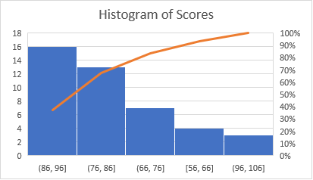

## Box Plot:

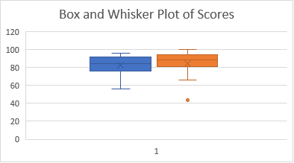

## Probability Distribution:

|  |  |
| --- | --- |
| X | P(X) |
| F | 0.042 |
| D | 0.083 |
| C | 0.375 |
| B | 0.375 |
| A | 0.125 |

## 5. Data Interpretation:

* Class A consistently performs better than Class B, as their scores seem to have more of a narrow spread centering around 80.5 as their mean. The minimum was 66 and maximum was 88.
* Compared to Class A, Class B shows a wider distribution of scores that range from a minimum of 72 to a maximum of 100, with average of 87.3. This can show more variation in the average student’s performance of Class B.
* Combining the data from both classes, we can see a bimodal distribution showing around 80-86 and 88-94, which may indicate that there was different difficulty levels of the exam or different topics were more challenging to each class.
* A majority of students fall within the C and B grade ranges, and fewer students received either an A or D grade. There weren’t many students who scored inside of the F range.
* To an instructor, this data could be worth investigating the differences in performance of their students in two different classes (populations) in which exams may need to be altered in difficulty level or fairness. We can also use this data as a student to identify areas that could be improved on.
* The wide spread of scores shows that this exam may not appear too easy or too difficult, but students in Class B may benefit from additional tutoring, studying, or resources available to help their spread in wider scores.